# Chapter 6 - Other Project Issue

## 6.1 Limitation

Some of the limitation of Library Management System are:

* System is not suitable for online booking or purchase of book.
* Software is suitable for small and medium scale library.
* User interface (UI) need to be improved.
* Entire data will be collapsed if software is corrupted.

## 6.2 Future Work

While designing system there are some feature that are excluded. So those feature are added to complete in future.

* Forget password confirmation.
* Student can’t delete their profile.
* Need to develop online booking or purchase of work.
* Need to develop user friendly interface for easy use of the system.

## 6.3 Risk Management

It is the procedure used by job managers to reduce any possible difficulties that may undesirably influence a project's schedule. Risk is any unpredicted occurrence that might distress the persons, procedures, technology, and resources involved in a project.

Risk management includes the following tasks:

* To recognize risks with their respective causes.
* Categorize and arrange the all possible risk.

From the above risk listed in proposal, the risk which I face is memory crash, insufficient feature and insufficient time to complete the project. So, due to arise of above risk I tend to fail to add additional feature like student update profile.

## 6.4 Configuration Management

Configuration management is a system manufacturing procedure for starting and preserving reliability of a creation's act, practical, and bodily attributes with its requirements, design, and operative information during its lifecycle.

The following reason for using software configuration management

* Changes in requirement of the project.
* Needs to change the project schedule.
* Due to uncertain change of Government rules and regulation.
* It helps to reduce the redundancy of project.

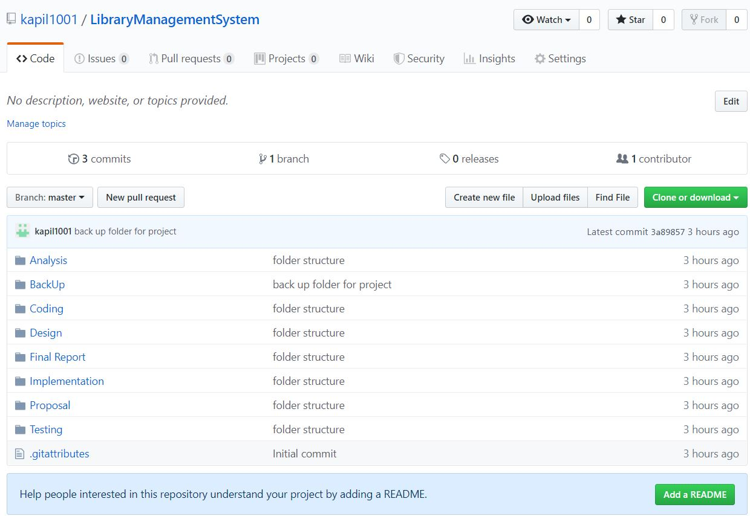

Figure GitHub directory of Library Management System.

For the safety of project I have created a backup folder where there are sub folders (Analysis, design, coding, testing etc.) for describing each stages of the project. As well as I have created GitHub account named kapil1001 for online backup where all folders are stored for future use. The main reason for using GitHub account is code that has been used previously can be reused here which helps to save time for project. Below is the link of GitHub Directory <https://github.com/kapil1001/LibraryManagementSystem>.

As well as, I have created backup in my local PC. Below is the project local backup directory.

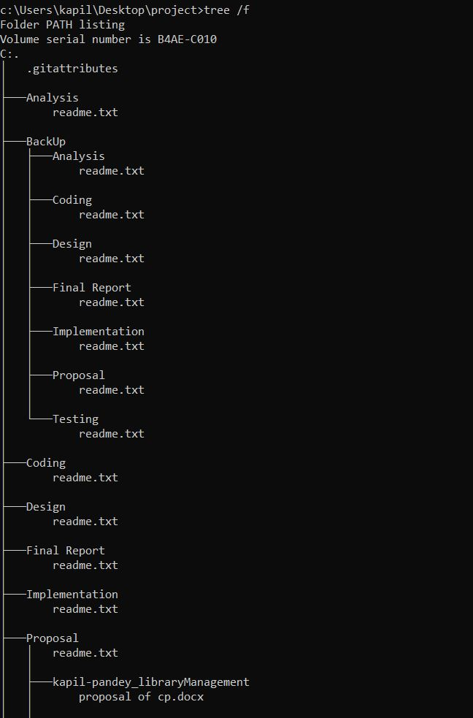

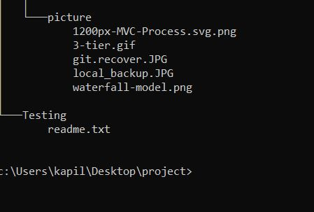

Figure Project Local backup Directory.

## 6.5 Other Project Issue

I don’t face any problem while developing this project because all the tools and software that are used in this project is free of cost and open source.

## 6.6 User Manual

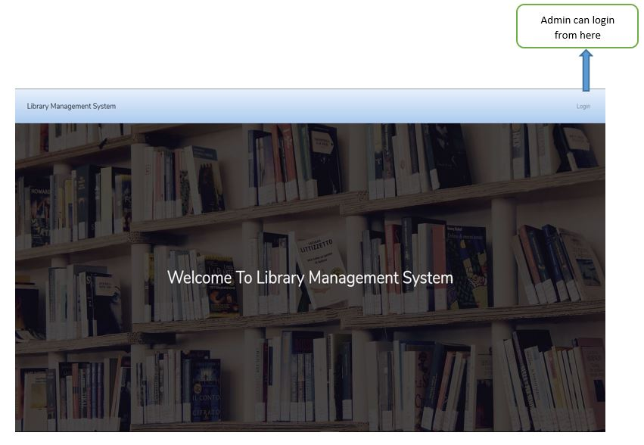

Figure welcome page of library management system.

This is start page where login form open by clicking login button.

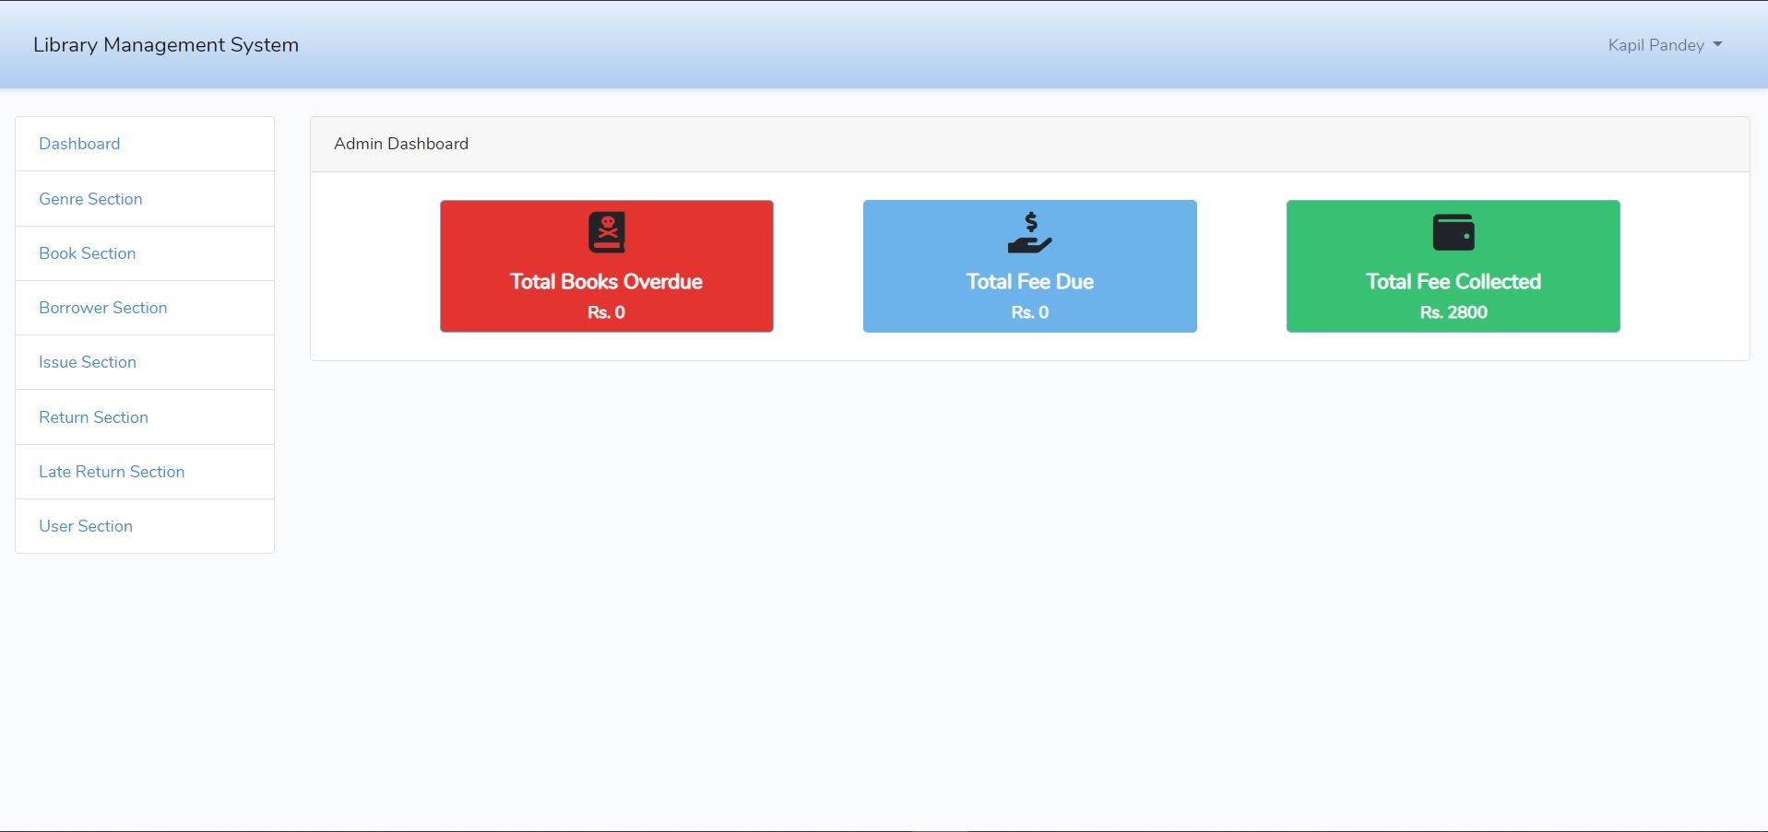

Figure admin dashboard.

After successfully login then it open admin dashboard where admin can add, delete, update and view books and students.

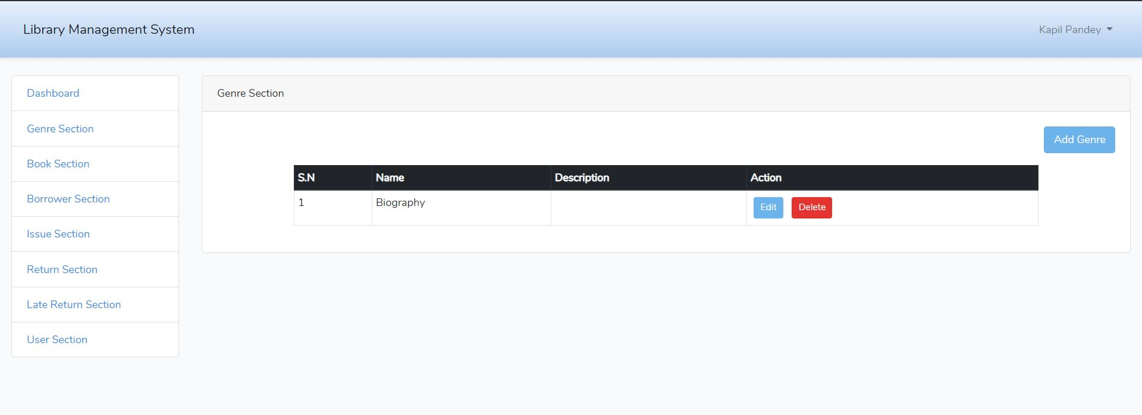

Figure genre section of library system.

In this section admin can add genre and description of books like whether book is biography or action or science fiction. Admin can also edit and delete genre.

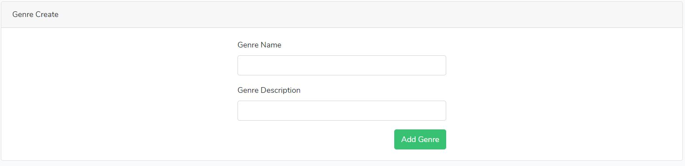

Figure form to create genre.

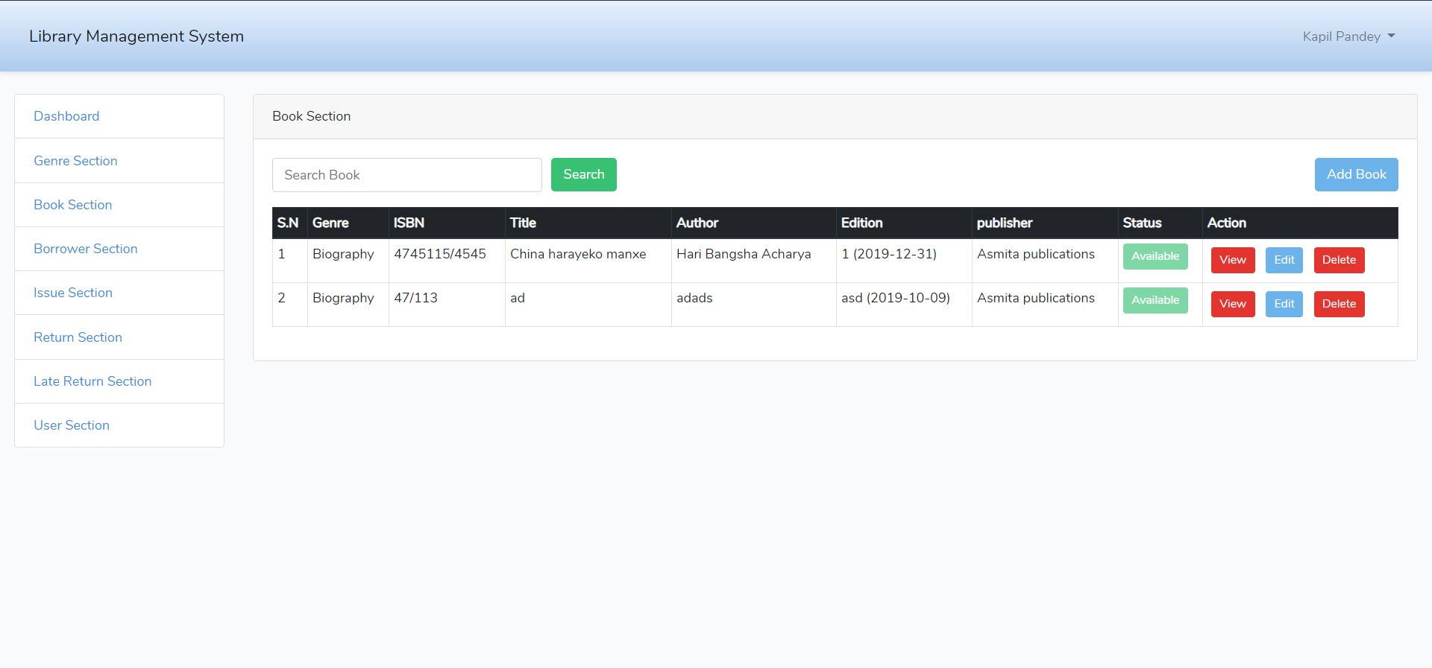

Figure book section.

From this page admin can add the books, search books, check the availability of book, edit, delete and view the books.

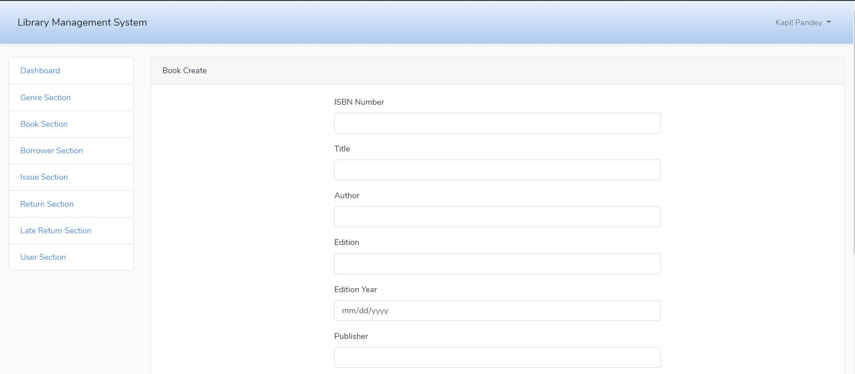

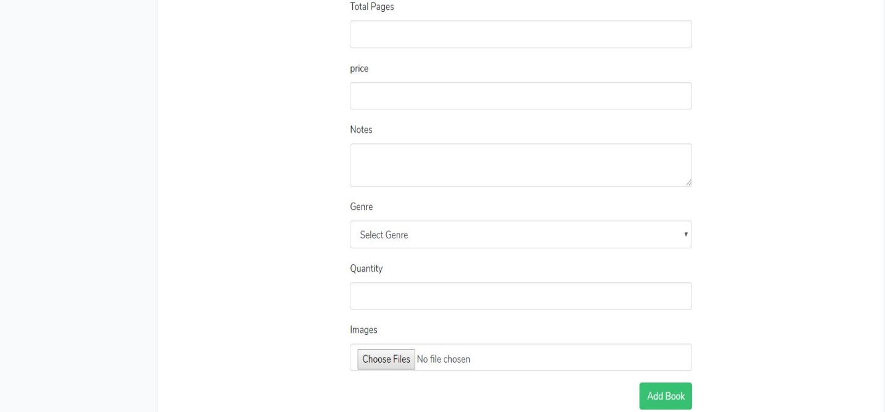

Figure adding new book by admin.

In this form admin can the books detail.

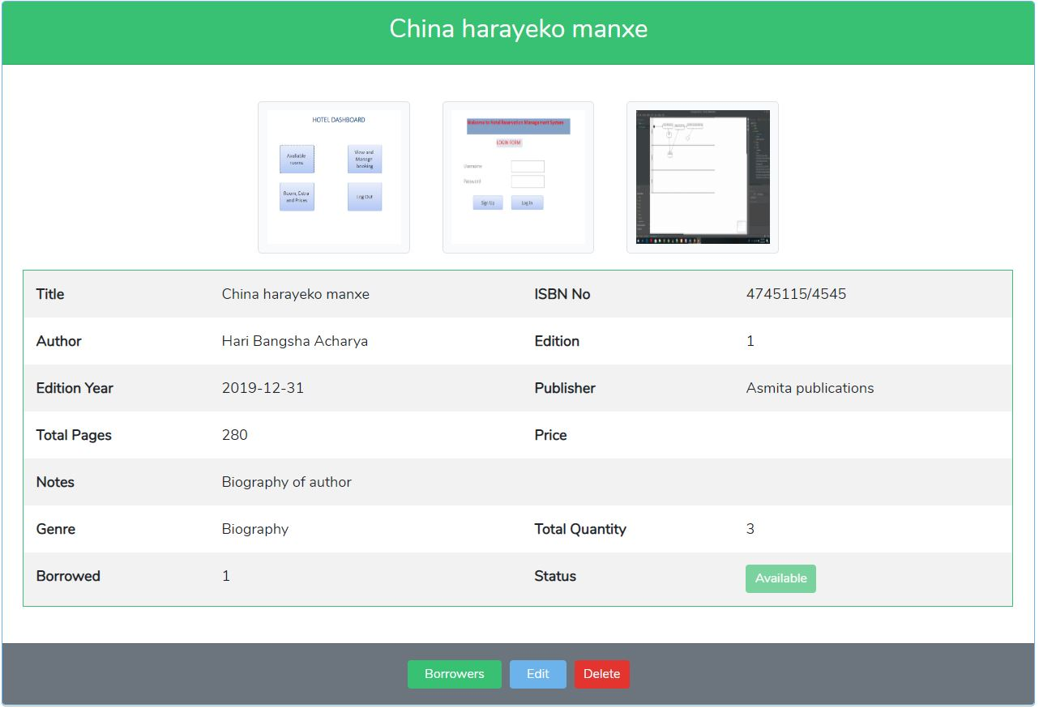

Figure view of books details.

From this page admin can view the books details and can see how many borrowers take this book, as well as he/she can edit or delete books from here

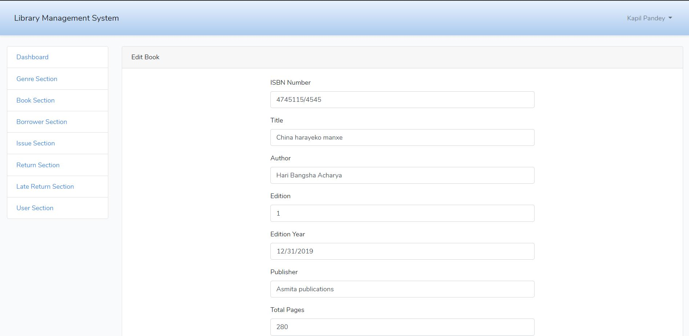

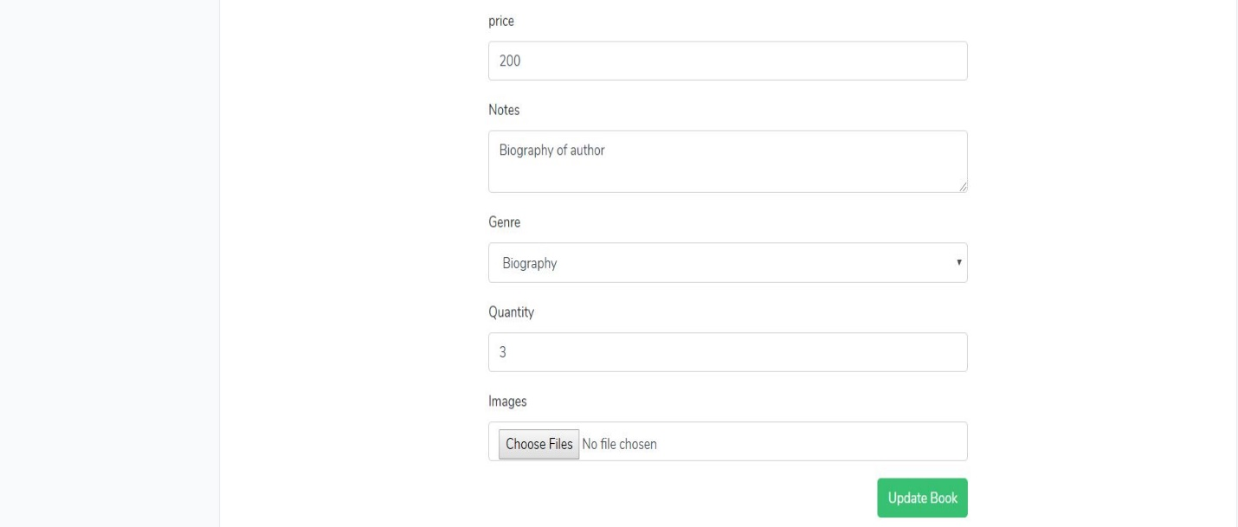

Figure update books details

Admin can update the books details after clicking on update bottom.

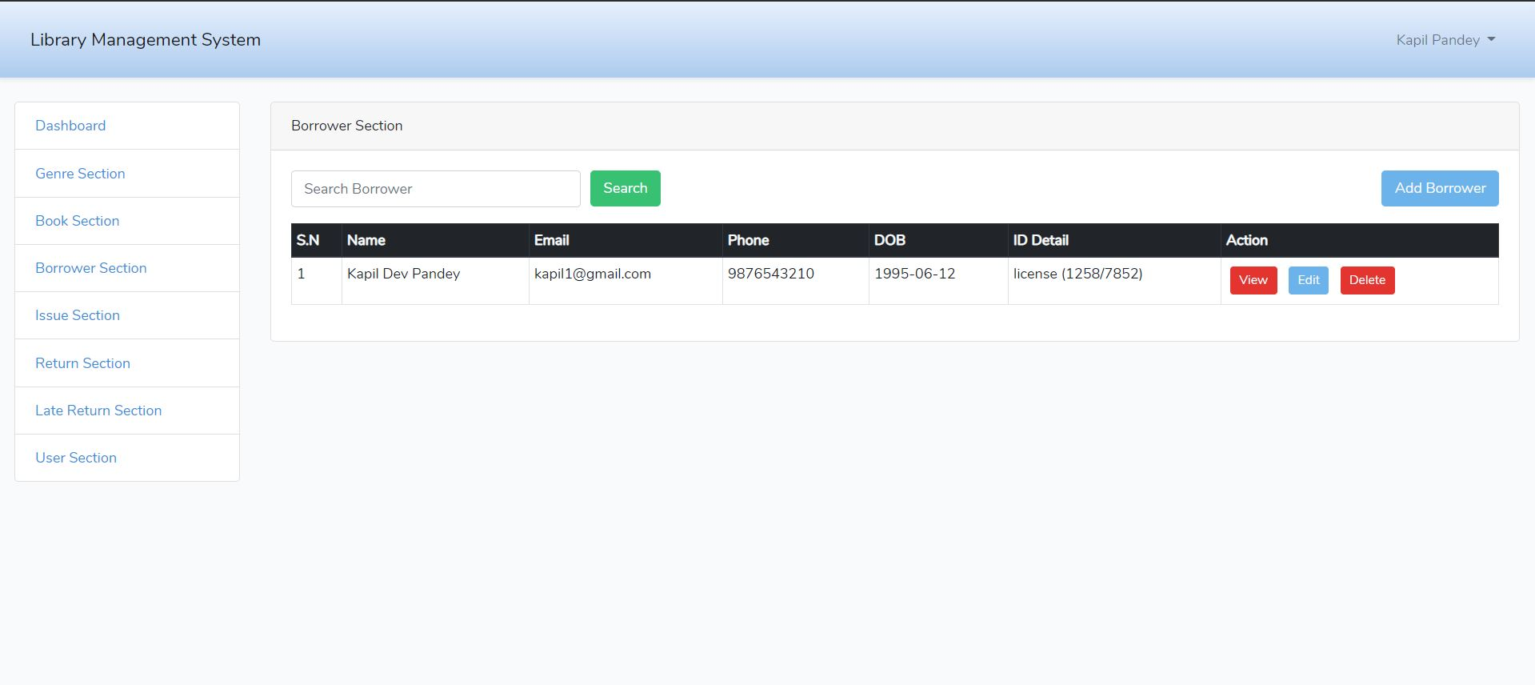

Figure borrower section.

From this page admin can see the list of borrower and can add, view, search, edit and delete the borrower details.

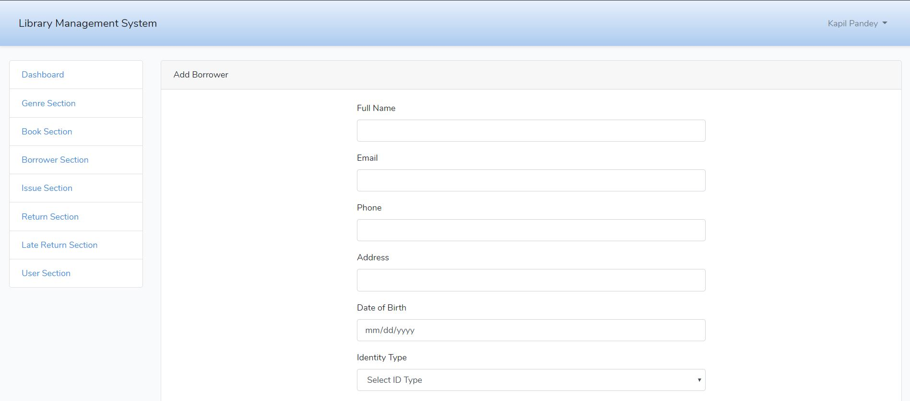

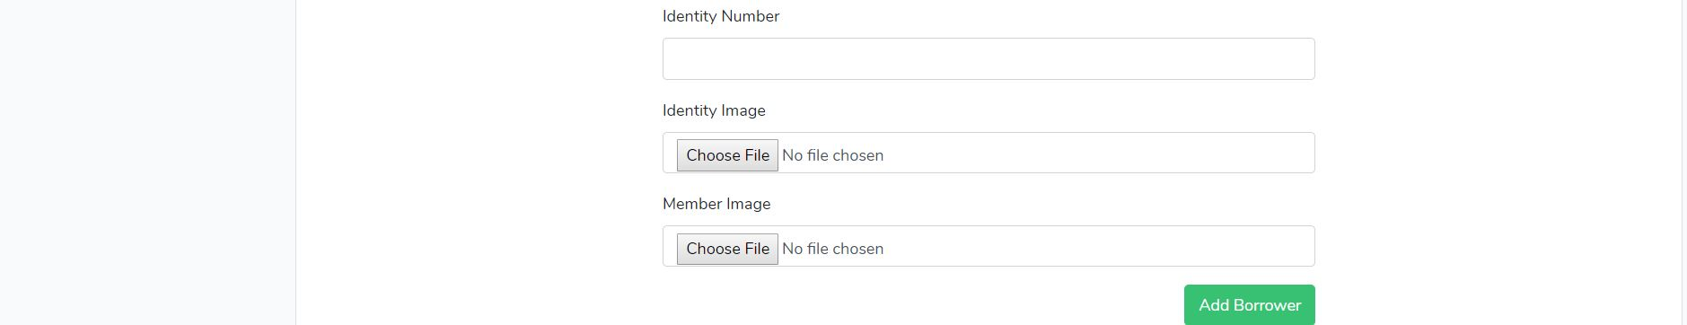

Figure borrower form.

Admin can add the borrower details in this form.

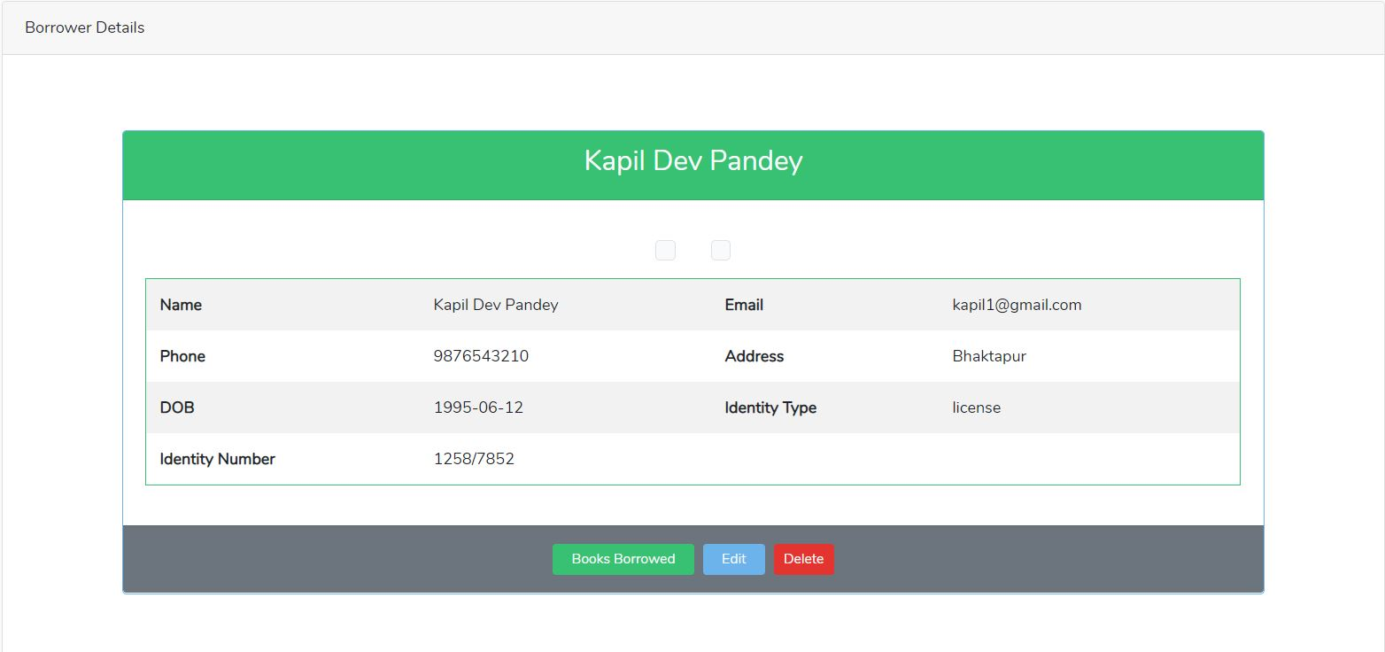

Figure borrower details

Admin can see the student who borrowed the books and can edit and delete borrowers.

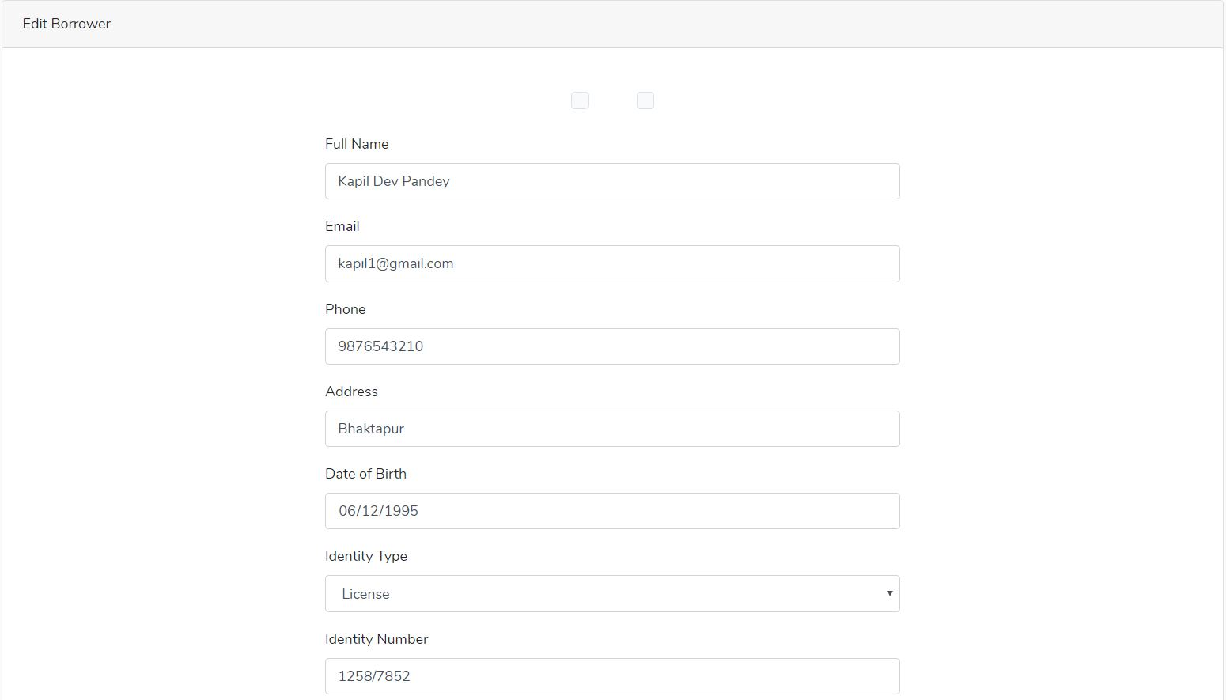



Figure update borrower form.

Admin can update the borrower details from that form.

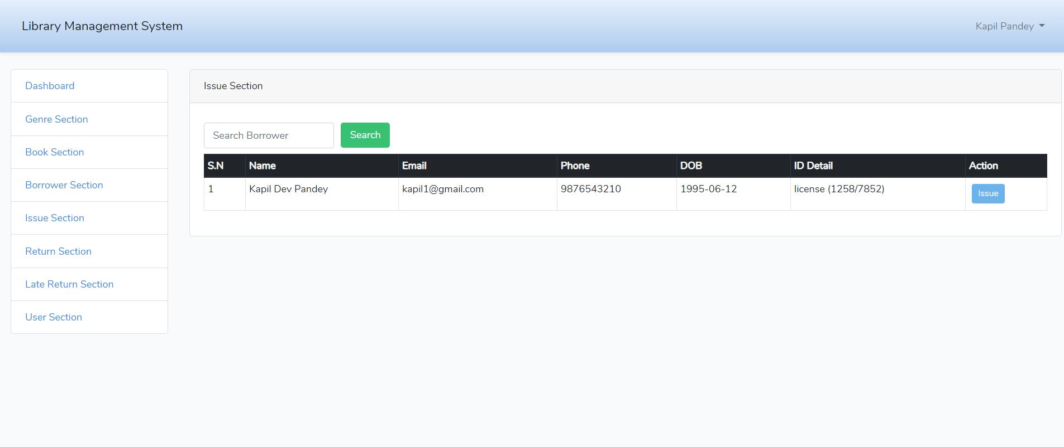

Figure issue section.

Admin can issue the book and search to whom book has been issued.

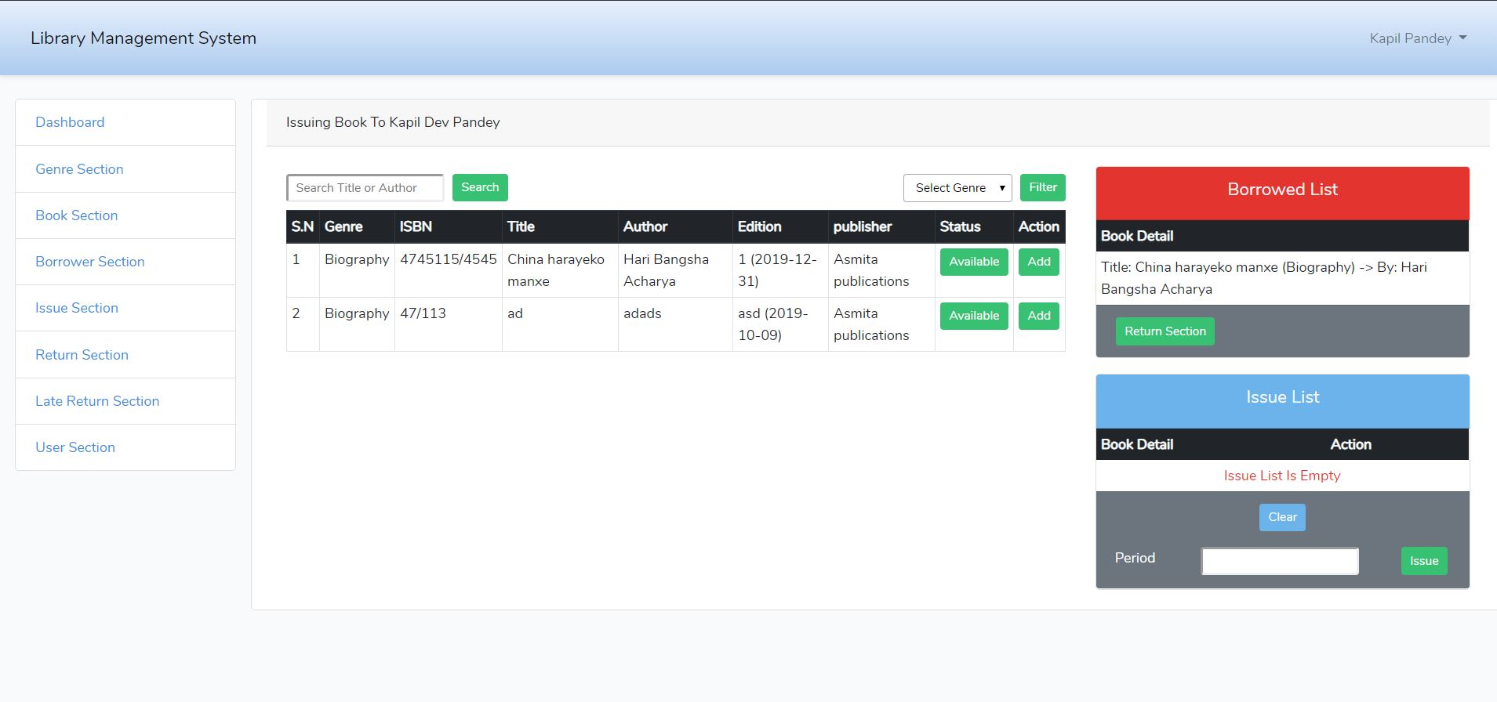

Figure issuing book detail.

From this page admin can know issuing book detail. He/she can search book according to title or author. Admin can check the availability of book. If it is available then he/she can issue the books to student. Admin can also view list of issue books issued by student. Admin can issue books to student for certain period of time if student fails to return then student will be charge fine for late return.

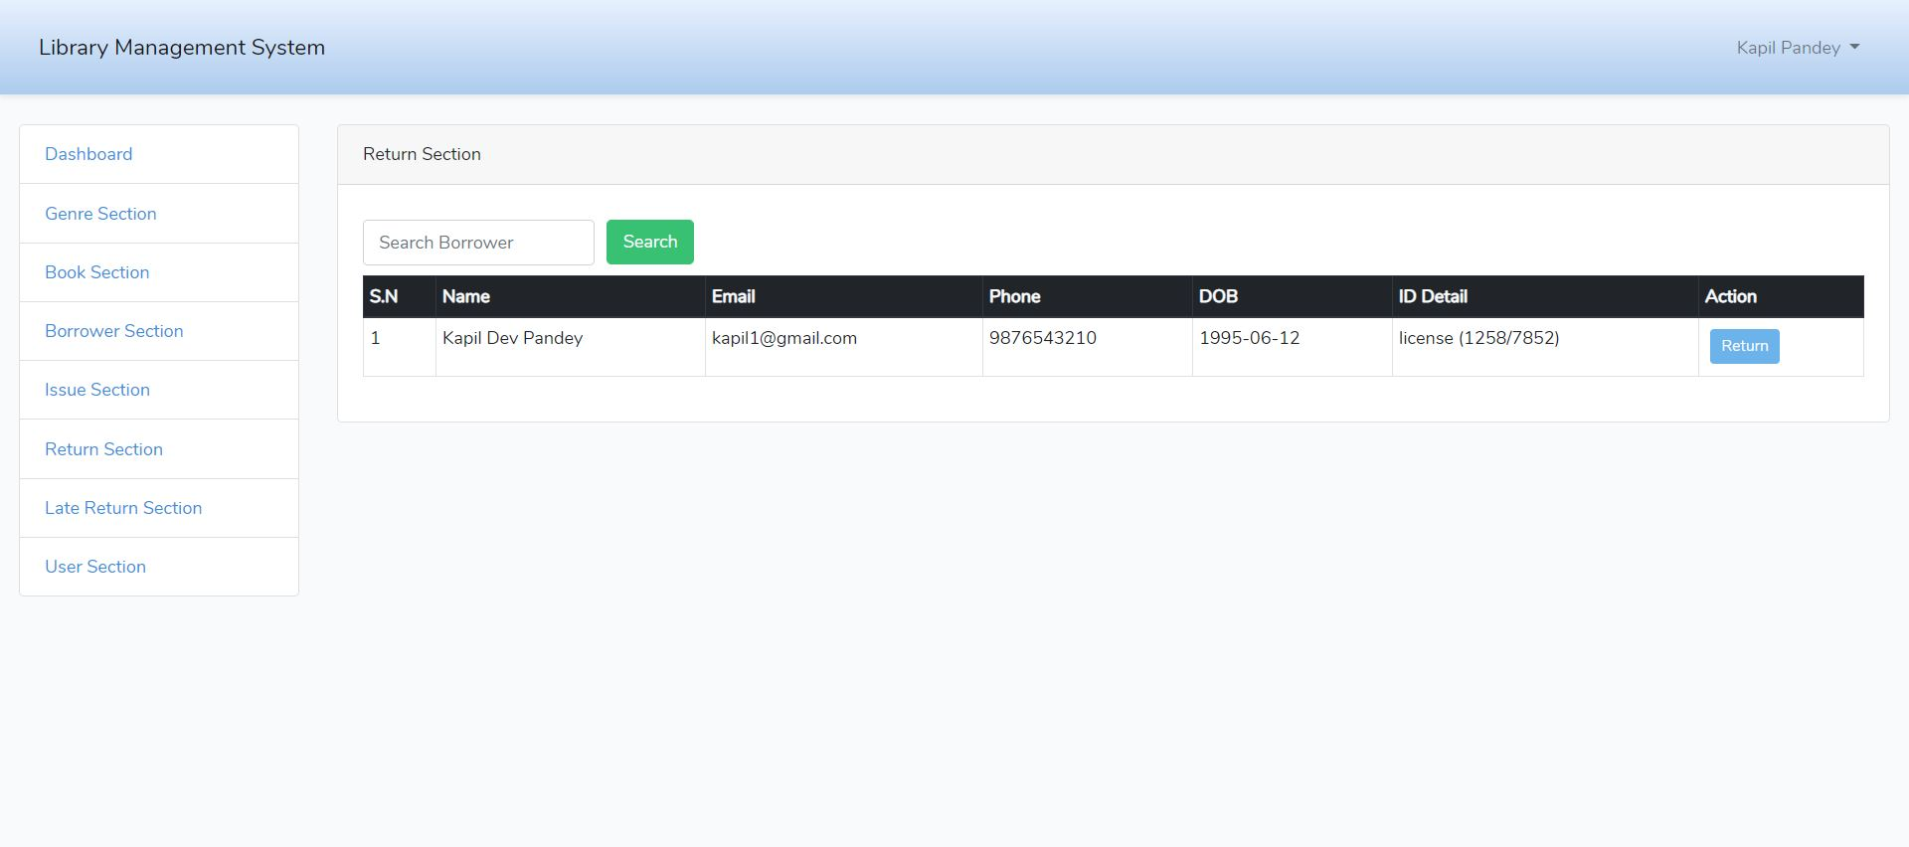

Figure return book

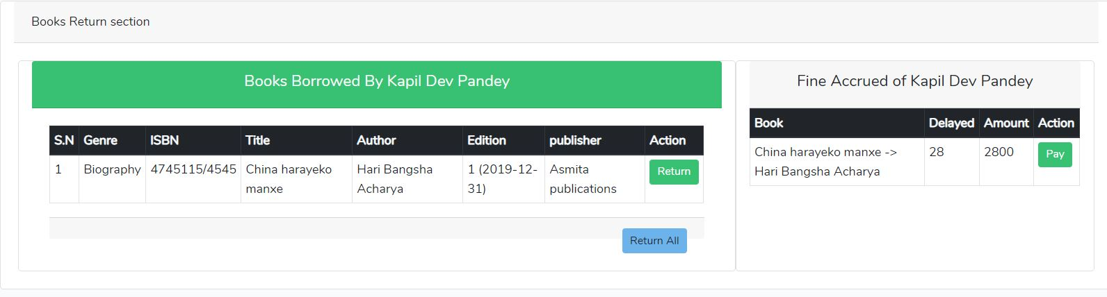

Figure fine accrued for late return

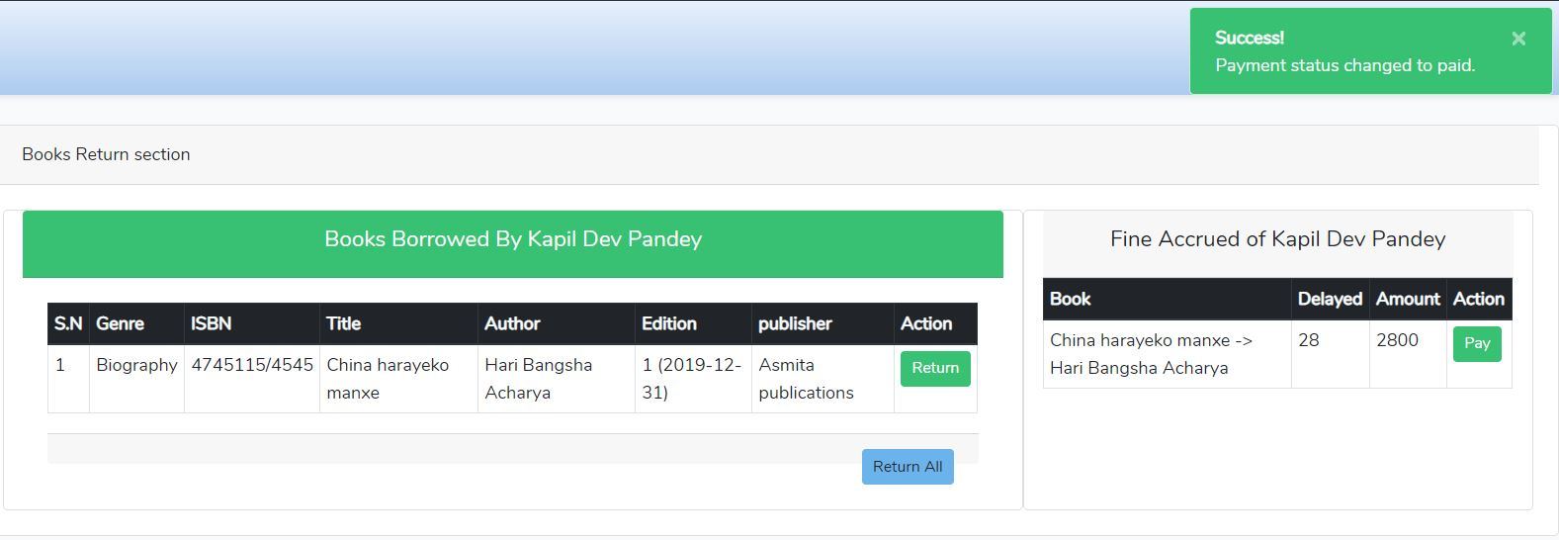

Figure after fine is paid then student can return book.

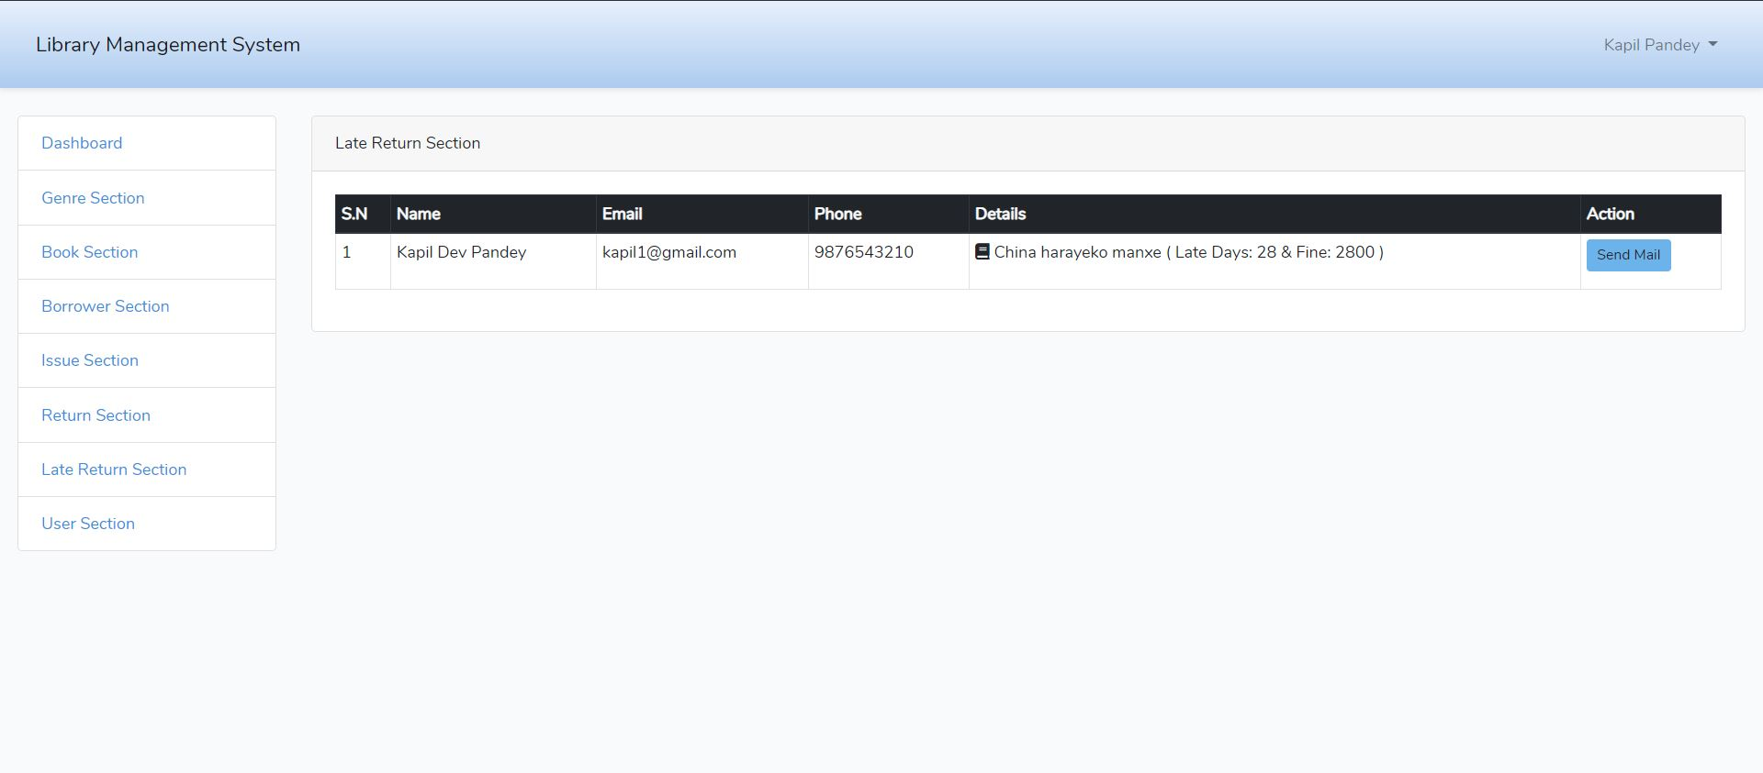

Figure late return.

If student fail to return book on time then from admin section mail will be sent to student mail for late return book and fine them.

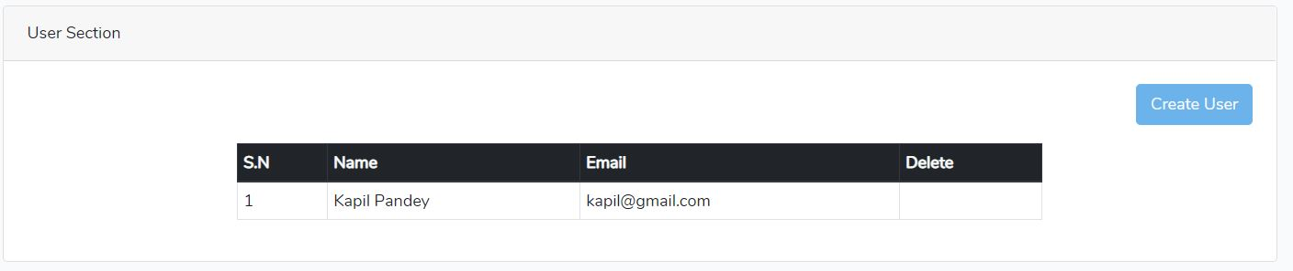

Figure user section

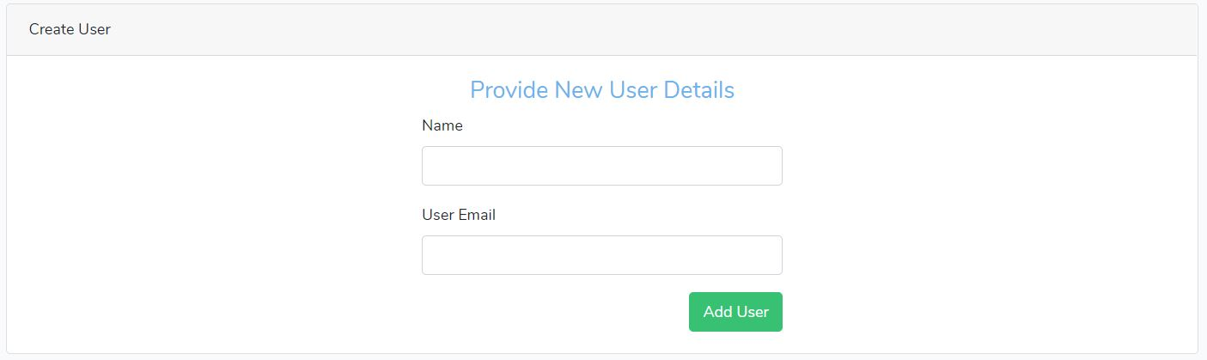

Figure can add new user from this form

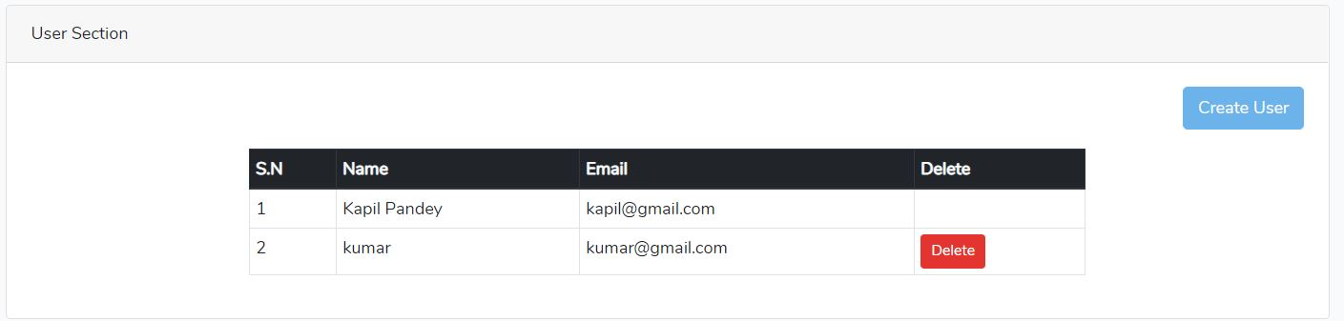

Figure can delete user from here.